|  |  |
| --- | --- |
| EGC_Black | **MATHEMATICS:SPECIALIST 3 & 4**  **SEMESTER 2016**  **TEST 4**  **Calculator Free** |

Reading Time: 2 minutes

Time Allowed: 33 minutes Total Marks: 33

1. [12 marks - 2, 3, 1, 2, 2, 2]

Determine the following:

a) b)

c) d) 

e) f)



2. [8 marks – 4, 4]

Part of the graph of the function $f\left(x\right)=\frac{2x+4}{x^{2}+2x-3}$ is shown below

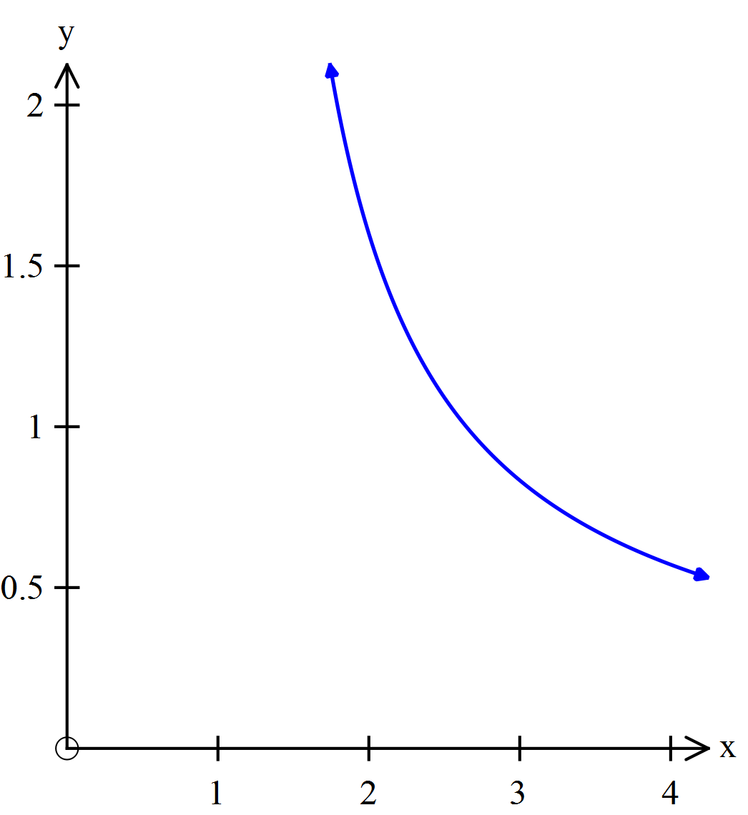

1. Use partial fractions to show that $f\left(x\right)=\frac{1}{2(x+3)}+\frac{3}{2(x-1)}$
2. Show that the area under the graph of $y=f(x)$ between and is

3. [8 marks – 4, 4]

1. Determine
2. Determine

4. [5 marks]

Evaluate $\int_{0}^{1}{ x {(2x-1)}^{3}} dx$ using the substitution 

|  |  |
| --- | --- |
| EGC_Black | **MATHEMATICS:SPECIALIST 3 & 4**  **TEST 42016**  **Calculator Assumed** |

Reading Time: 2 minutes

Time Allowed: 23 minutes Total Marks: 21

5. [6 marks - 2, 2, 2]

(a) An unknown function is such that its table of values are given below.

|  |  |  |  |  |  |  |  |  |  |  |  |
| --- | --- | --- | --- | --- | --- | --- | --- | --- | --- | --- | --- |
| x | 3 | 4 | 5 | 6 | 7 | 8 | 9 | 10 | 11 | 12 | 13 |
| f(x) | 13 | 13.8 | 14.1 | 14.6 | 15.3 | 15.7 | 15.9 | 16.5 | 17.1 | 18.6 | 20.1 |

Using the midpoint rule with 5 strips, determine the approximate area under the function between x = 3 and x = 13.

(b) Determine the area under the curve of $\text{f}\left(\text{x}\right) \text{=} \frac{\sqrt{\text{x}}}{\text{ln}{\text{x}}}$ between x = 2 and x = 10 using Simpson’s rule with strips of width 0.5. Give your answer to 6 decimal places.

(c) An unknown function is such that its table of values are given below.

|  |  |  |  |  |  |  |  |  |  |
| --- | --- | --- | --- | --- | --- | --- | --- | --- | --- |
| x | 1 | 1.5 | 2 | 2.5 | 3 | … | 10 | 10.5 | 11 |
| f(x) | 8.2 | 8.175 | 7.6 | 6.625 | 5.4 | … | 46 | 59.025 | 74.2 |

The formula for the trapezoidal rule is:

$$\text{A ≈ }\frac{\text{w}}{\text{2}}\text{ × }\left[\text{f}\left({\text{a}}_{\text{0}}\right)\text{ + 2}\sum_{\text{i=1}}^{\text{n-1}}{\text{f(}{\text{a}}_{\text{i}}\text{)}}\text{ + f(}{\text{a}}_{\text{n}}\text{)}\right]$$

Given that $\sum{\left(\text{8.2} \text{+} \text{8.175} \text{+} \text{7.6} \text{+} \text{…} \text{+} \text{74.2}\right) \text{=} \text{333.2}}$ determine the approximate area under the function between x = 1 and x = 11 using the trapezoidal rule.

6. [8 marks - 4, 2, 2]

The graphs of  and  are shown below:







(a) The expression for the shaded area (above) can be written in the form: .

Determine expressions for b and c.

(b)Determine the values of *a* and *b*, if it is known that: , when .

c)Determine the area of the shaded region to two decimal places. Working is not required.

7. [7 marks – 3, 4}

1. Find the exact volume of the solid of revolution formed when the line

$3x+4y=36$ between the limits $y=1$ and $y=7$ is rotated about the y-axis.

1. When the same line, $3x+4y=36$, is rotated about the x-axis between the limits $x=1$ and $x=a$, the volume of the solid of revolution formed is $\frac{489π}{2}$.

Determine the value of $a$.